 | 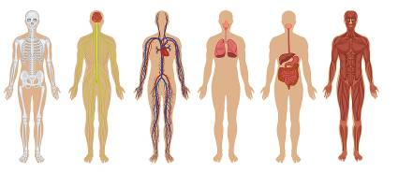 | 2nd UK and Ireland Exposure Science Meeting

March 4, 2014
Manchester Central Convention Centre, Manchester, UK

http://www.coeh.man.ac.uk/ExpSci2014/

Abstract Submission Form
Please submit your abstract by completing the form below and returning it via email to frank.devocht@manchester.ac.uk before December 2nd, 2013.

Indicate preferred presentation (tick box) |  | Oral |  |  | Poster
Abstract title
Authors
Abstract text (Max. 300 words)
Contact details of presenting author | Name:
 | Institution:
 | Email:
 | Telephone:

ALL PRESENTERS ARE EXPECTED TO REGISTER FOR A PLACE AT THE MEETING

